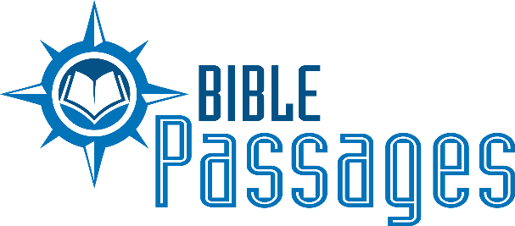 2019 Highlights

Please see http://www.biblepassages.net/biblepassagesreports for our monthly reports.
The following is a short summary of what God has allowed us to do during 2019.

1. Bear Valley Bible Institute: From January to March we worked with 39 full-time students at Bear Valley Bible Institute International in Denver, Colorado. From August to October we worked with 37 full-time students. Courses taught included 1 and 2 Thessalonians/Philippians; Bible Geography; Church History; Divided Kingdom; and Homiletics. I also conducted, during chapel, a non-credit short course mini-series on Christian Counseling.

2. We worked with various US congregations for preaching appointments, gospel meetings, teacher training, marriage seminars; and apologetics seminars. Those places included Bear Valley in Denver; Hydro, Oklahoma; Forest Hill congregation in Memphis, Tennessee; Willette, Tennessee; Windsor, Colorado; Brighton, Colorado; Mesa, Arizona and Wahiawa, Hawaii. In Texas, we worked in League City, Mathis, Buna, Kirbyville, and Schertz. We also worked at the Polishing the Pulpit Seminar delivering lectures and conducting several counseling sessions for participants.

3. Working abroad, I preached in Nazareth, Israel, and also narrated and directed the filming of the documentary “Go Now to Shiloh.” I also participated in the archaeological dig at Shiloh under the direction of the Associates for Biblical Research. Later in the summer, we continued to document the geography and archaeology of the Bible Lands by capturing drone footage and other film footage of over 19 biblical sites. In July, Carla and I participated in an archaeological dig at a site in the Judean Shephelah at Tel Burna, which is believed to be biblical Libnah.

4. In the month of May we led a group of 47 Christians on a 13 day studies program in Israel. The program was called the Digging Deep Tour which featured speakers Glenn and Cindy Colley.

5. Writing assignments for lectureships and books: (1) Bear Valley Lectureship on 1 Corinthians 3:1-9; (2) Schertz Lectureship on Genesis 42-43; (3) Freed-Hardeman Lectureship on the topic “Balancing Humility and Confidence: 1 Corinthians 12:7; (4) Devotional articles for the “His Life” devotional series published by the Jenkins Institute.

6. Carla continues her work as a columnist for Christian Woman publishing an article for each issue. She also conducted ladies days at Hydro, Oklahoma; League City, Texas; Brighton, Colorado; and Buna, Texas. She also delivered lessons at the University church of Christ in San Marcos, Texas; Forest Hill in Memphis, Tennessee; and Schertz, Texas, and taught the accredited class “Marriage and Family” in the Bear Valley Bible Institute Women’s Study program. She has also begun writing a monthly column for the online women’s group “Come Fill Your Cup”.

7. WVBS released Passages 11 and 12 of the Bible Land Passages Documentary Video Series. Passage 11 is called “The Power of Jesus in Galilee”, and Passage 11 is called “The Tomb of Jesus.”

8. Completed the first phase of the Bible Lands Photograph project. Over 1000 photos were labeled and organized and published. These photos, as well as video footage captured over the last few years in Israel, continue to be used in numerous projects published by both Apologetics Press, Inc., and World Video Bible School.

9. Counseled several couples and individuals, including couples and families in ministry.

10. Produced and released the Shiloh documentary; a BLP Special Edition. This included script writing, narration, and the directorship of all phases of the project. We also released a DVD of this project with 25 minutes of extra bonus material.

11. We continue our work on Bible Land Passages 13, “Caesarea: Rome’s Capitol City in Israel.”

12. As revealed in our monthly reports, we continue to hear of souls being baptized.

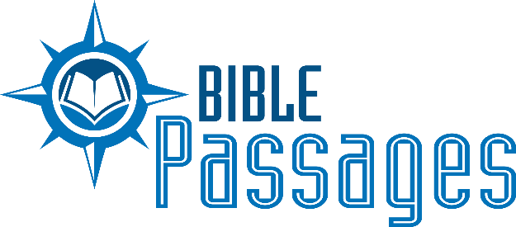
2020 Ministry and Work Calendar (as of November 2019)

January 2 – March 2—Teaching classes on campus at Bear Valley Bible Institute International. This year for the first time in school history, we will be offering an undergraduate course in Christian counseling.

February 6th – Speaking at Freed-Hardeman University, Henderson TN

February 16 – Speaking at Dripping Springs, TX

March 2-14—Teaching and Directing BLP Studies Program for Bear Valley Bible Institute (Greece and Israel)

March 15-27—Teaching and Directing BLP Studies Program for Christians from the US (Israel and Rome)

April 1 – 30—Working on WVBS Projects and Bible Land Passage documentaries, writing, and preparation

May 1-3—Delivering a series of lessons at the Middle Tennessee Men’s Leadership Retreat

May 15-17—Bear Valley Bible Institute Graduation Weekend

May 18-June13—Evangelism and Edification program in Brandon, England.

July - Working on WVBS Projects and Bible Land Passage documentaries, writing, and preparation

July 19-25 Peach Valley Youth Camp

July 28 – October 5th Teaching classes on Campus at Bear Valley Bible Institute International in Denver

August 16-22 – Polishing the Pulpit (Tentative)

October 8-11 – New England Lectures in Tilton, NH

October 15-18—Linder Road Lectures on Archaeology and the Bible, Meridian, Idaho

October 23-25- Marriage Seminar South Highway Five church of Christ building in Lebanon, MO

November-December - WVBS Projects and Bible Land Passage documentaries, writing, and preparation

TBD: Marriage Seminar and Gospel Meeting in Wasilla, Alaska (arranged but dates not yet confirmed).
We are particularly interested in presenting materials on Archaeology, Geography, and other historical information that confirms the reliability and validity of scripture. This never fails to strengthen faith and confirm the truth of God’s word! If you are interested in hosting a seminar like this, or other topics, please contact us. Our schedule is more flexible than most and we’d love to visit with you about it!

