Marriage Seminar
Areas of Emphasis

The Rules of the Road: Marriage is like traveling in a vehicle down the road of life, but that journey can bring its own unique set of challenges and issues. To reach our destination safely and to enjoy the ride along the way, we have to know the rules of the road. This session considers the practical and helpful rules found in Colossians 3 for traveling down the road of marital happiness.

Roadblocks and Detours: Death to Destructive Habits - Movement toward a destination can be impeded by accidents, landslides, floodwaters, and work crews. These roadblocks and detours are frustrating and often dangerous. In this session some of the roadblocks which impede progress toward marital happiness are explored. Special emphasis given to the peculiar issues relating to husbands and wives are examined.

Road Rage: Managing the Conflicts – Conflict and the anger that often accompanies it, is a fact of life. Like road rage, anger and resentment are dangerous to your marital safety. How couples communicate and manage their disagreements is critical to marital health. In this session couples will be given practical advice for dealing with anger and how to properly communicate and resolve conflict.

Repairing the Engine. When a vehicle breaks down and doesn’t function properly it creates a lot of frustration and worry. Dysfunctional marriages and families result in similar disturbances. What can we do to address and repair the dysfunction occurring within our own homes, or within in the homes of our friends and neighbors? Numerous biblical principles and constructs offering a remedy will be examined. Attention is also given to book of I Corinthians and how the apostle Paul sought to correct the family dysfunction occurring within the church.

Knowing your Passenger: Sexual Intimacy in Marriage - In the marriage relationship, one of God’s greatest gifts is the emotional and physical intimacy to be shared between a husband and wife. Sadly, Satan uses God’s precious gift as one of his greatest tools in harming the marriage. Many couples often miss out on the joy and spiritual connection that can exist because they fail to follow the road map designed by God. Consequently, many couples never see the beautiful vistas and pleasant creation of the sexual relationship. This session focuses on practical advice and general principles for helping couples fulfill God’s plan for marriage and thereby to experience the apex of the sexual relationship.

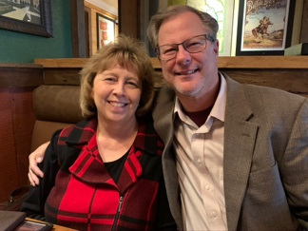
Enjoying the Ride: - In many ways marriage is similar to a journey. The quest to enjoy the ride can bring its own unique set of challenges. Various elements tend to impede progress. Valleys and hills are often encountered. The vehicle needs constant refueling. Yet, many couples are making the trip with great enjoyment. Their journey has taken them down many different highways, but overall their trip was filled with fun and wonderful experiences. This session will reveal some of those success stories and explore the principles discussed in the book Magnificent Marriage.

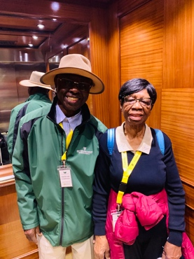
Fuel in the Tank Part I: While a vehicle may look and smell new, if doesn’t have enough fuel in the tank it won’t make it to the end of a long journey. Making sure you have the right fuel in the tank, and plenty of it, is absolutely critical for reaching your destination. In this session, examine the biblical precepts regarding love as the fuel needed and how to obtain it, as you journey down the road to happiness. This session will focus primarily upon the use of The Five Love Languages by Gary Chapman.

Fuel in the Tank Part II: While a vehicle may look and smell new, if doesn’t have enough fuel in the tank it won’t make it to the end of a long journey. Making sure you have the right fuel in the tank, and plenty of it, is absolutely critical for reaching your destination. In this session special attention will be given to meaning of true biblical love especially as it was revealed on the cross at Calvary.

A Family in Crisis and a Heart Struggling to Forgive: Families in the church may at times find themselves embroiled or enveloped by controversy. As a result a lot of hurt and resentment can permeate their lives. Are there examples in the Bible of families who have faced similar issues, or individuals who have struggled with forgiveness? This session will focus on the life of Joseph and his family and how anger, jealously, pride, and resentment tore apart their family. Special attention will be given to the need for forgiveness in marriage.

